Silver Lining

Site Plan

Overview

Site Purpose

This site has the job of giving a weather forecast for a week in advance. It will give helpful information about what events are open still, and what will close down because of rain or other bad weather.

Target Audience

The target audience is middle age to older people that live in Franklin and the surrounding area. It’s for those active in the community that are looking to see if events are still going on. They’re not comfortable with the internet, so this will need to be a user friendly site.

Color Guide

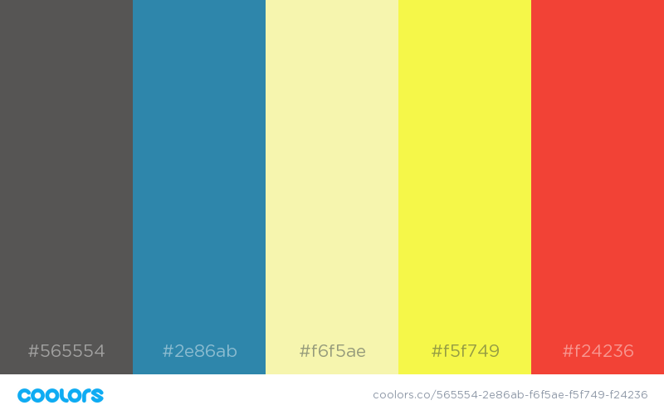

Text color Main link hue background accent accent

Colors were made to represent strongly heat, sun, and cooler temperatures.

Typography

Head typeface

Helvetica

Body Typeface

Times new romans